Lab 2

Creating Linux and Windows VMs Instances in AWS

In this lab, you will launch Linux and Windows virtual machines in AWS and attach to them from your lab workstation or your laptop.
Before start, [optional] only needed, if you are using a Windows machine/laptop.
If you are using a Windows computer, you are going to have to install a Linux shell environment. If you are using a Mac, you do not have to install a shell because Mac runs Linux! You need a Linux shell to connect to a Linux instance on AWS.
The Linux shell you are going to install is “Git for Windows” from here: https://git-for-windows.github.io/. Click Download. Run the executable after it has been downloaded.
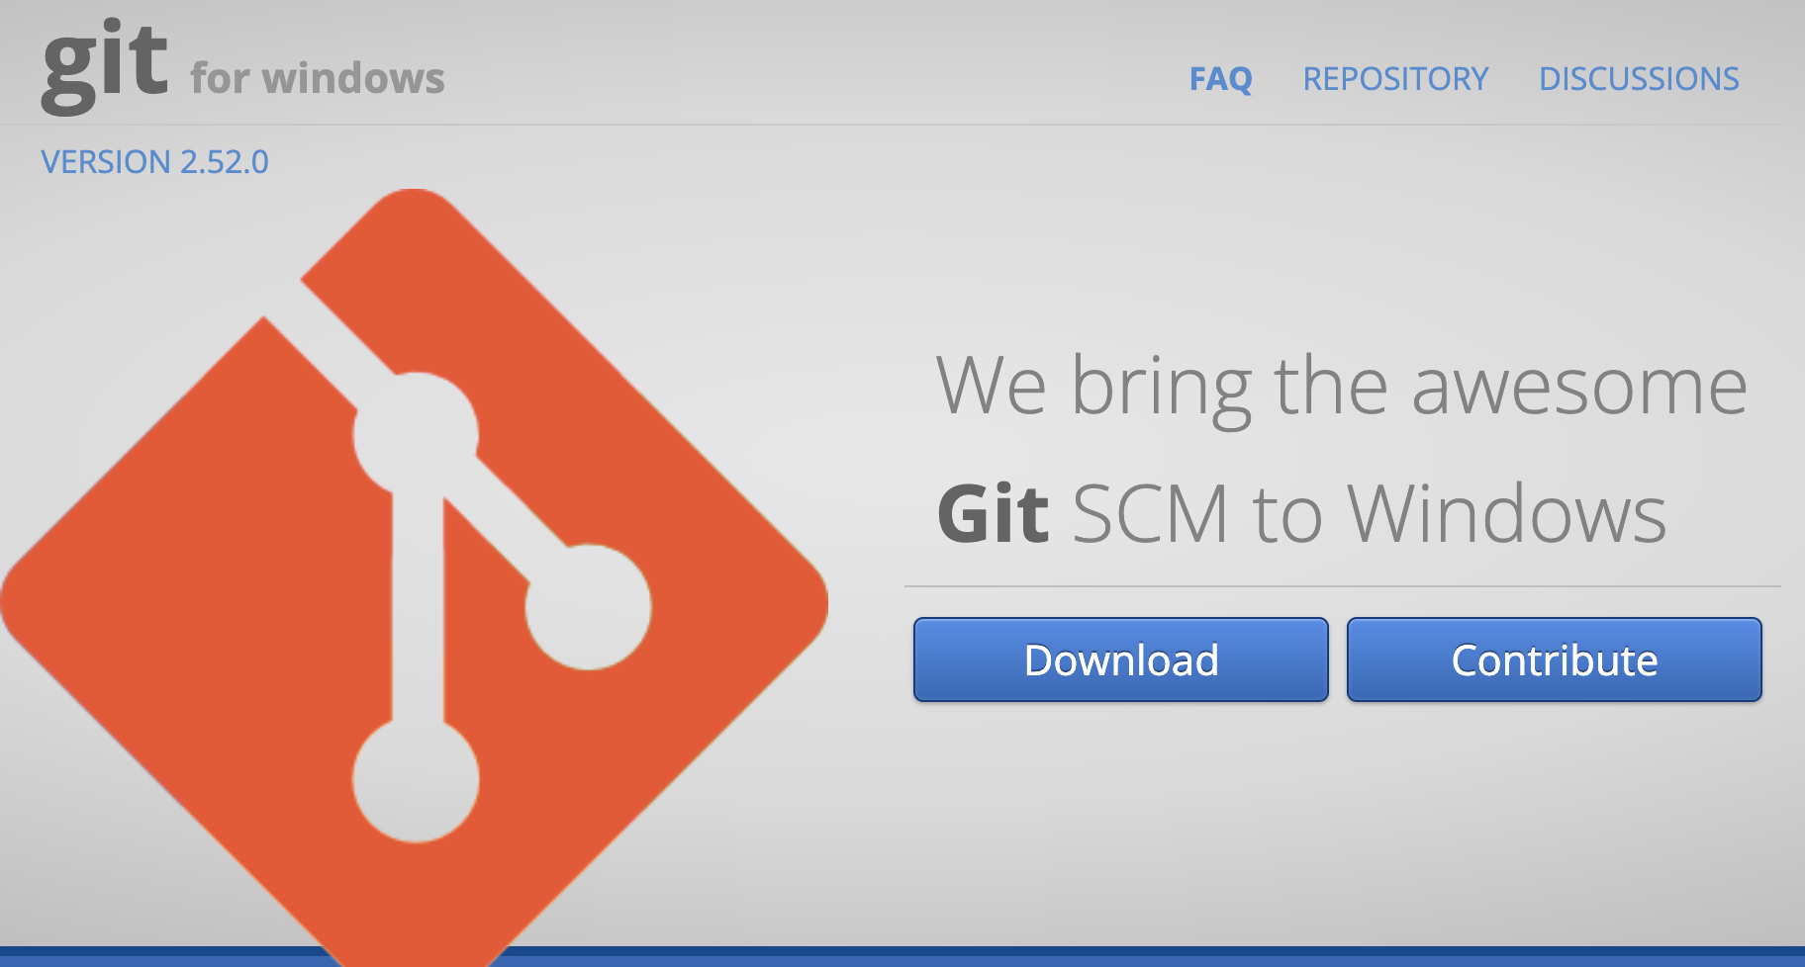
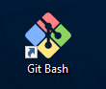
You should have an icon on your desktop that looks like this:

Double-click on the icon. This will open a Linux bash shell like this:
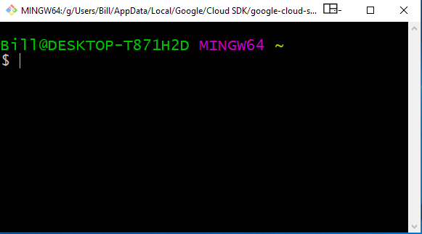
OK, now we are ready to go!

Part I: Launch a Linux instance

- Read the web page “Getting Started with Amazon EC2 Linux Instances” in Learning Hub under this lab. You should be able to complete this lab by following steps on that web page. Listed below is a quick summary of those steps.
- Log into AWS using the URL associated with your IAM user.
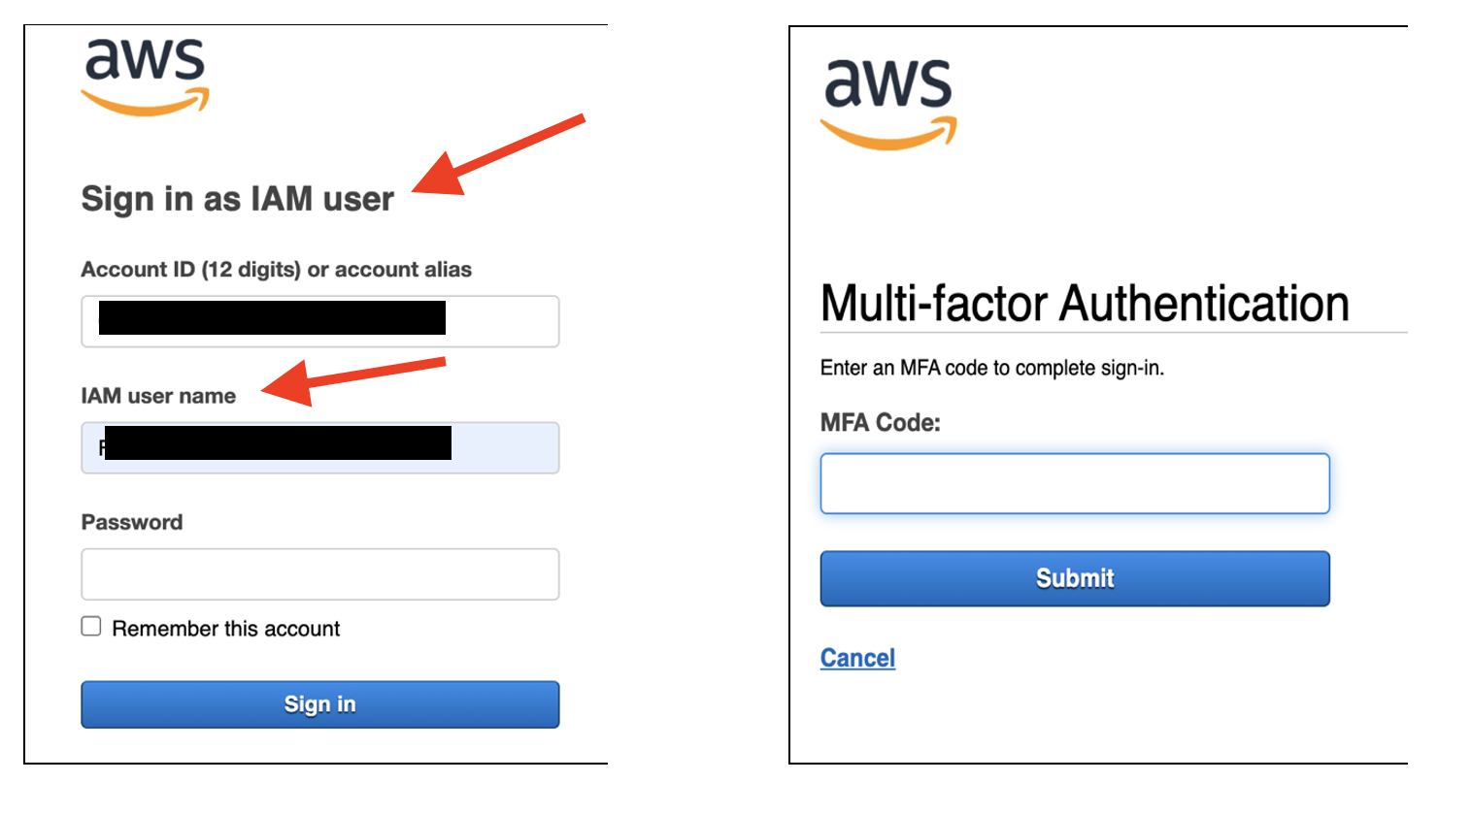

- Select US West (Oregon) data center (as your region). This is at the top-right corner of your screen next to your username. Note: us-west-2 is Oregon.
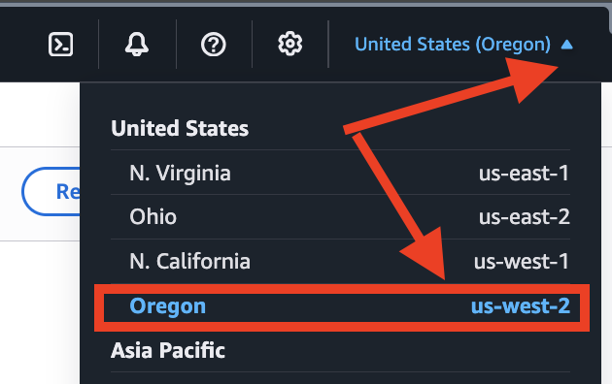
Note: if you are not in us-west-2, switch to it. Otherwise, the launching takes much longer.
- Type ec2 into the top search bar the main dashboard, then choose the EC2 service from the search result
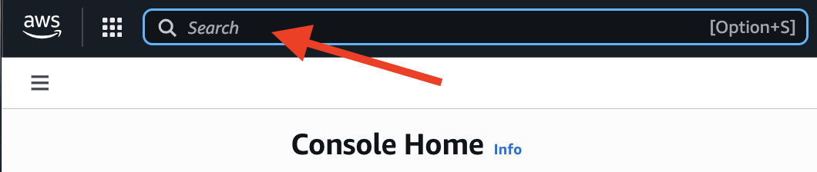
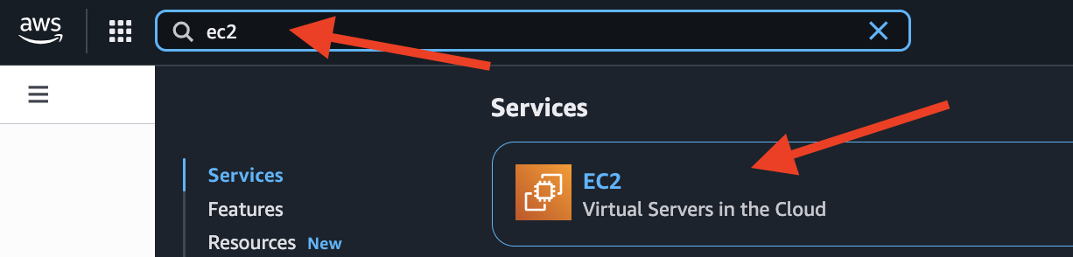

- Launch a free Amazon Linux EC2 instance.
  - Start with Launch instance button.
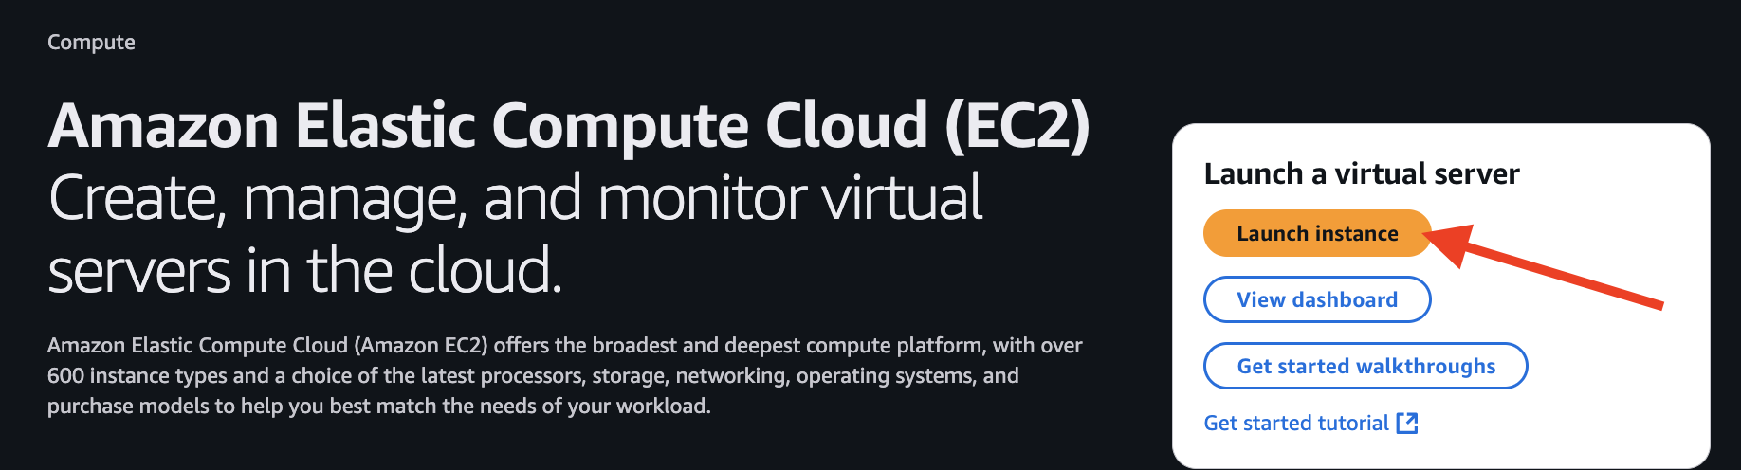
  - Under the Quick Start section, choose Amazon Linux (default) and go with default AMI
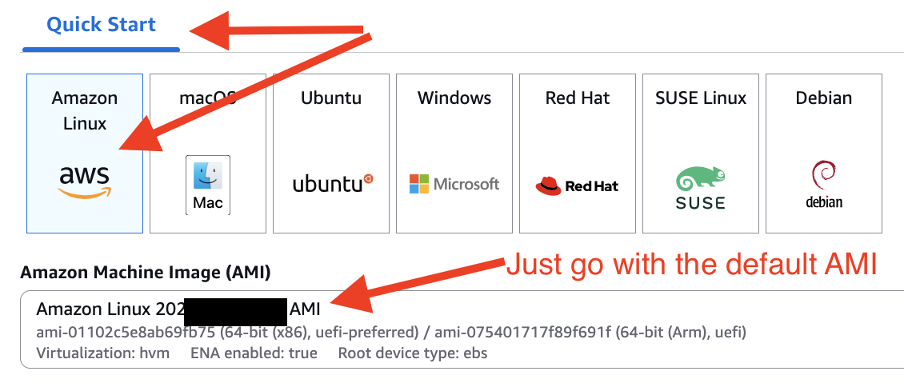

  - For “Instance type”, double check to use the default “t3.micro” with “Free tier eligible”.
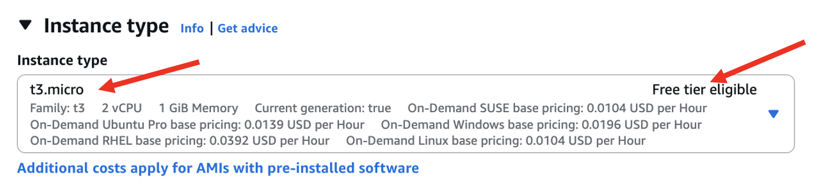
  - In “Key pair (login)” section, click on “Create new key pair.”
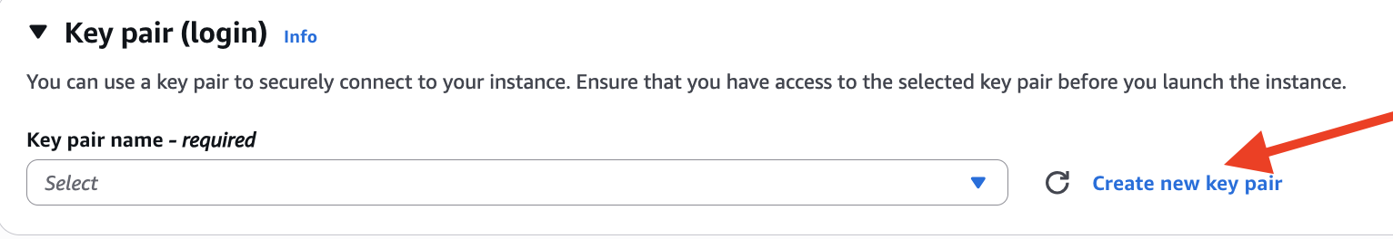
  - In the pop-up:
    - Enter your a-number as the name for the key pair
    - Double check default with “RSA” and “.pem”
    - Click Create key pair button to proceed.
  - The private key file is automatically downloaded by your browser. The file name is the name you specified as the name of your key pair, and the file name extension is .pem. Do not lose this file! You will use it for ALL your remaining labs.
  - Move this .pem file to the directory associated with your Git Bash shell. The path to the directory is shown at the top of your shell window.
For MAC and Linux users, just leave the .pem file into a folder you can find it in your terminal/shell.
  - Once you have moved the .pem file to that location, enter the Linux command “ls” in your shell window. You should see your .pem file listed.
  - In the “Network settings” section, just double check the defaults are aligned as “Create security group”, “Allow SSH traffic from” & “Anywhere” as follow:
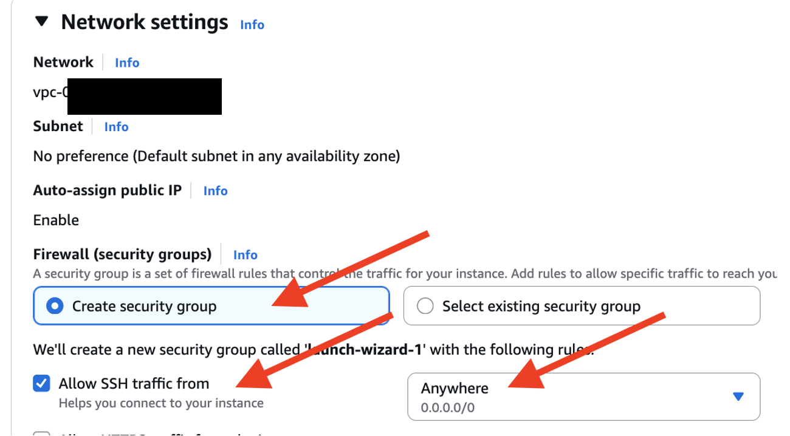
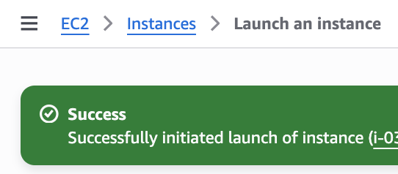
  - In the “Summary” section, click Launch instance button to proceed.
- Wait till seeing success message as:

- Go to instance dashboard, by clicking Instances in the lefthand side menu.
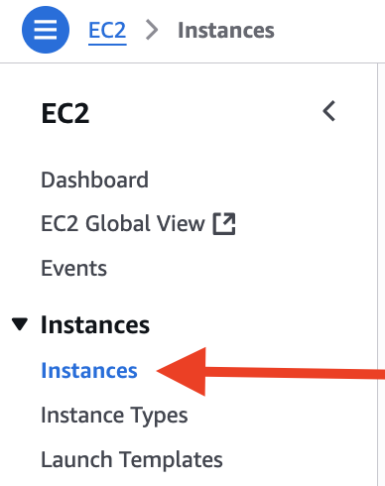
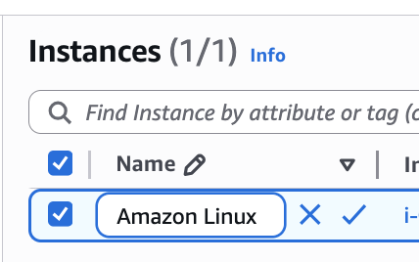
- Name your instance as “Amazon Linux”.

- Wait till the status of your instance is “running” & status check is “3/3 checks passed”.
- Now, we want to connect or log into the Linux instance.
- Click on the instance ID to open it
- Click “Connect” on the left-top corner of the detail page
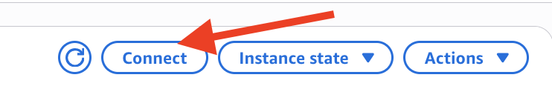
- Open the “SSH client” tab
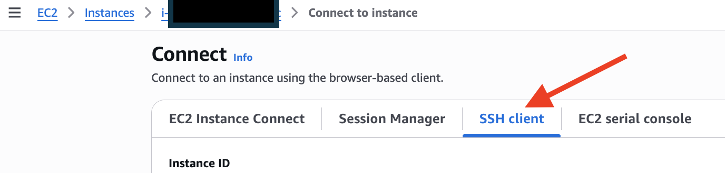
- Copy the showing ssh command.
- From the Git Bash window or your Shell or Terminal, enter the copied command:
ssh -i <pem file name>.pem ec2-user@<public IP address or url of your instance>
Eg,
Should see something like this:
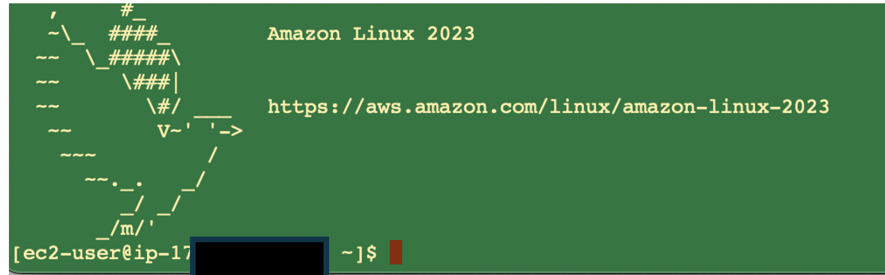

Note: At this step, you may get Error saying Permissions 0640 of your key is too open.
You can run chmod 400 [your_A#].pem and then run the above ssh command again
[Sign-off]
- Go to show your progress to your instructor to get sign-off.
  - One screen of your EC2 dashboard for a proof of your Linux instance is running
  - One screen of your console for a proof of your access to the instance
Note: if you got here outside of class time, you need to “Stop” your Linux instance.
Do NOT keep your instance “running” during waiting for sign-off.
[Teardown – after signing off or passed the due]
- Go back to your EC2 Dashboard, select your instance.
- From the Instance state dropdown menu, select Terminate instance to delete the Linux instance.
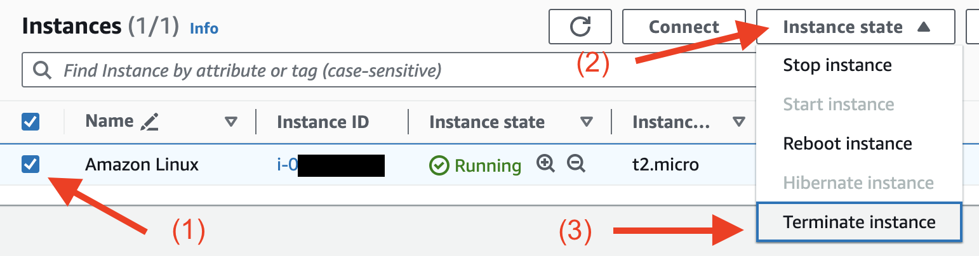
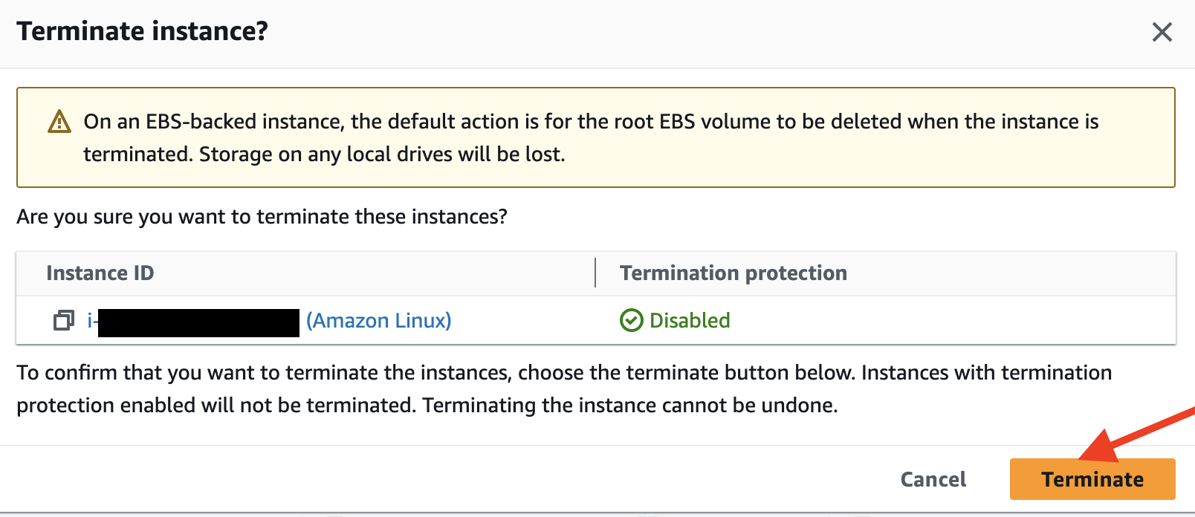

Part II: Launch a Windows instance

- Log in with your IAM user (You’ve already done so in Part I)
- Get into EC2
- Click Instances on the navigation pane on the left of.
- On the top of the screen, click the orange button Launch instances .
- In Quick Start section, choose “Windows”
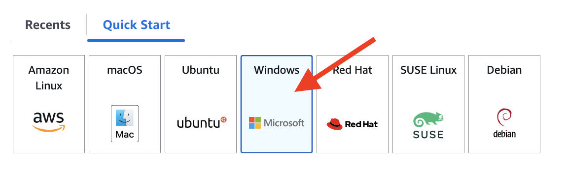
- For the machine image, verify the default one is “Free tier eligible”.
If no show “Free tier eligible”, find one in the dropdown list.
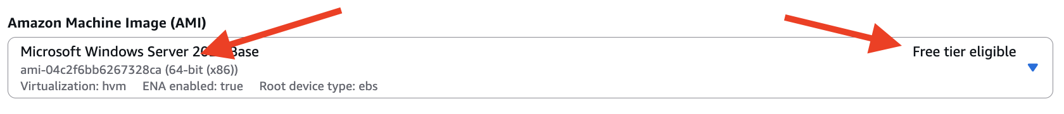
- For Instance type, double check to use the default “t3.micro” with “Free tier eligible”.
- For Key pair (login), Choose your own keypair (created earlier) from the dropdown.
- Under Network settings section, for Firewall (security groups) verify the defaults as “Create security group”, “Allow RDP…” and “Anywhere 0.0.0.0/0”
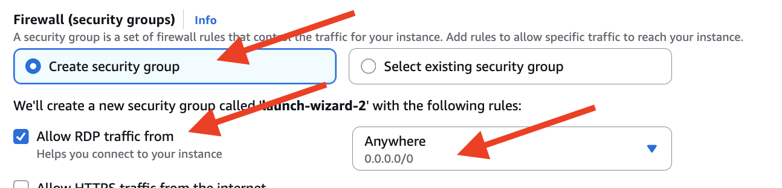
- Launch your instance and record the Instance ID: _________________
- Once you have launched your Windows instance, following the instructions on this website to connect to your image: http://docs.aws.amazon.com/AWSEC2/latest/WindowsGuide/connecting_to_windows_instance.html

[Sign-off]
- Show listed screens to your instructor, to get sign-off:
- One screen of your EC2 dashboard for a proof of your Windows instance is running
- One screen to show your access to the Windows instance, something like this:
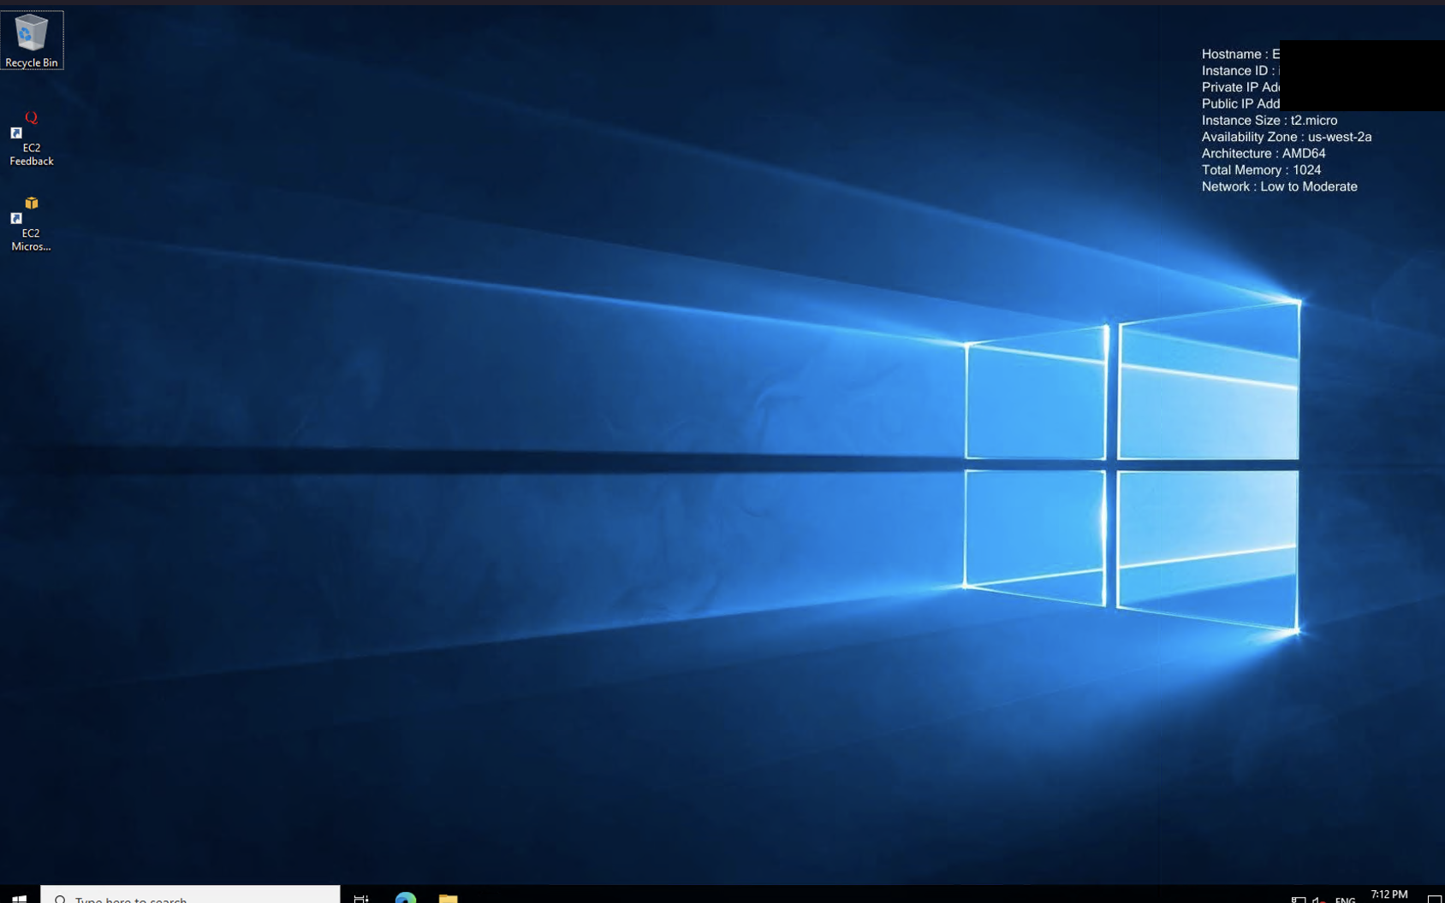
Teardown:
- To terminate your instances (NOT just “stop”)
Ask your instructor to sign off your teardown after your instance(s) got terminated.

